Ron Cohan
Photographer

Ron Cohan is an amateur photographer with a professional talent to focus on incredible coastal views. He has lived in Dana Point over 45 years and gets his inspiration from the beauty of nature that surrounds us here in Southern California.

Some of Ron’s stunning images feature the morning and evening skies overlooking Dana Point Harbor. He uses the camera on his Apple phone. He has an eye for capturing the colorful hues and the details of the sky. One of Ron’s photos was selected to be in this year’s Orange County Fair.

Ron retired from his career as the owner of a gallery of southwest jewelry and art in 2014. He now works as a Tai Chi and Qigong instructor for the City of Dana Point and the City of Mission Viejo, while he continues to pursue his passion in photography.

If you would like to contact Ron about his photography or about taking one his very popular Tai Chi and Qigong classes, please contact him at zia3@cox.net

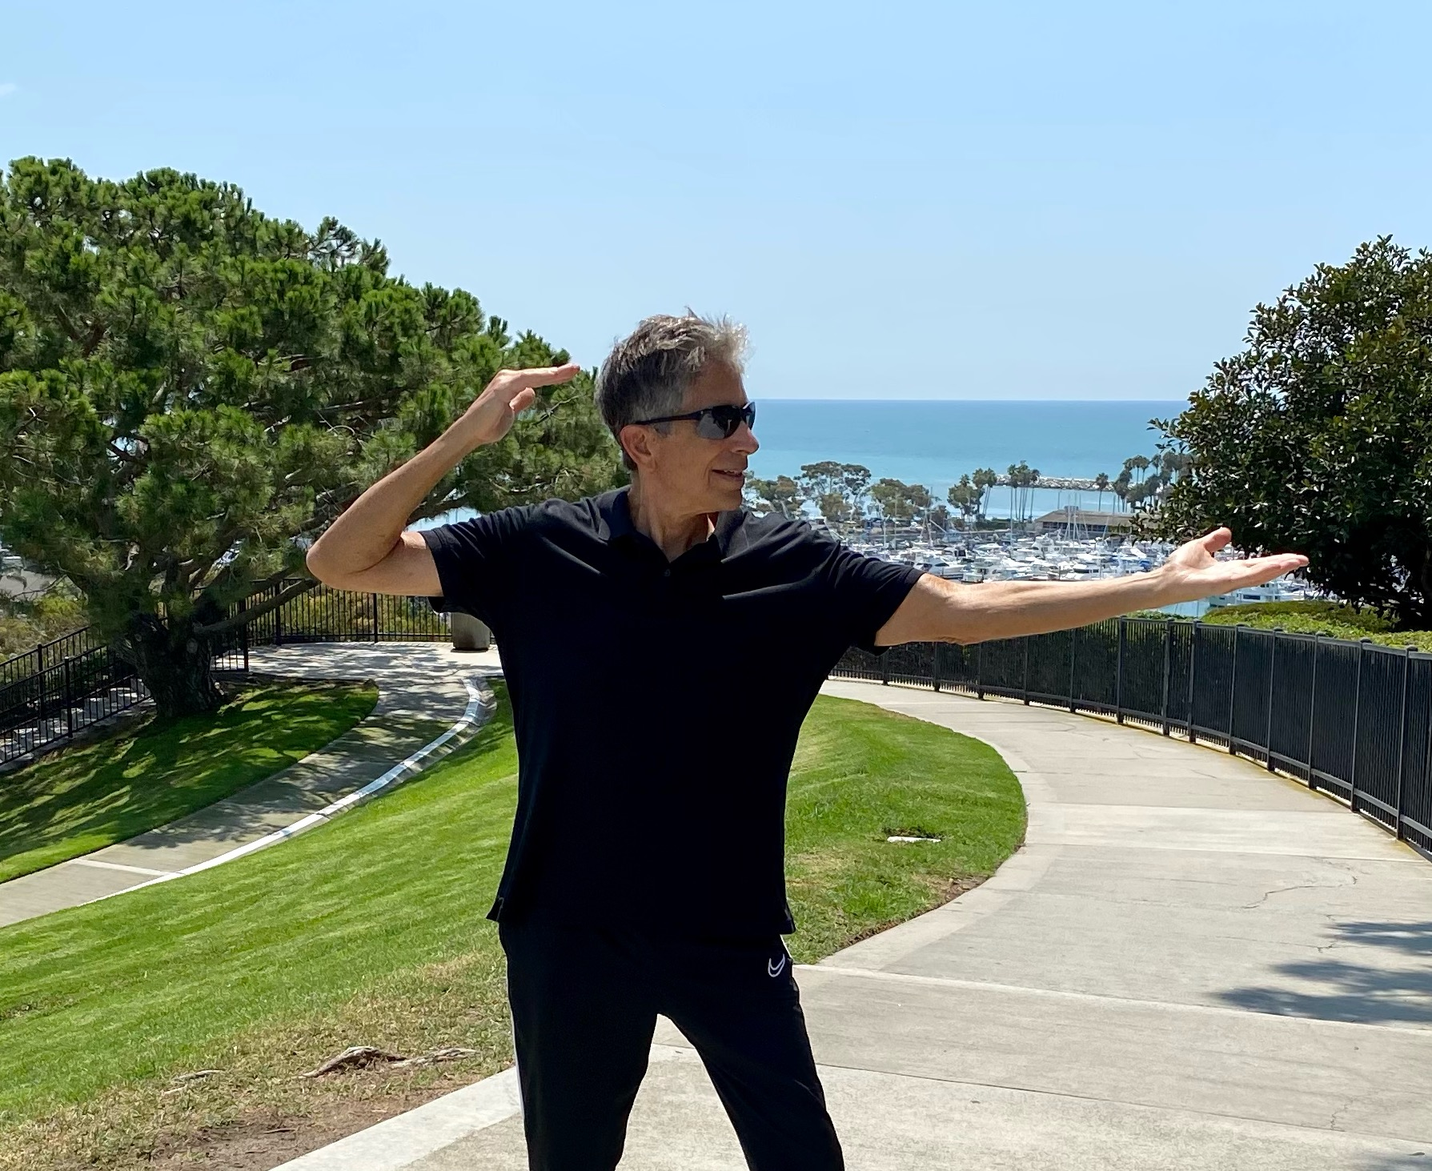 | 